**IT24102561**

**Modarage K.R.**

**PS Lab Sheet 05**

**Exercise**

1. A close up of a computer code

   Description automatically generatedA screen shot of a computer

   Description automatically generatedImport the dataset (‘Exercise-Lab 05.txt’) into R and store it in a data frame called “Delivery_Times”.
2. Draw a histogram for deliver times using nine class intervals where the lower limit is 20 and upper limit is 70. Use right open intervals.

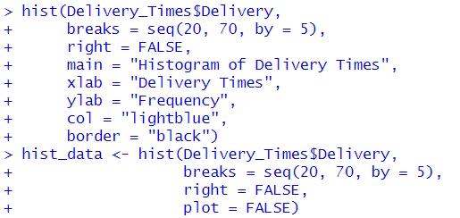

1. Comment on the shape of the distribution.



1. Draw a cumulative frequency polygon (ogive) for the data in a separate plot.



